Udemy Lecture On SalesForce Cloud Computing…

----------------------------------\*\*\*\*\*\*\*\*\*\*\*\*\*\*Lecture 1 Start\*\*\*\*\*\*\*\*\*\*\*\*\*\*\*------------------------------

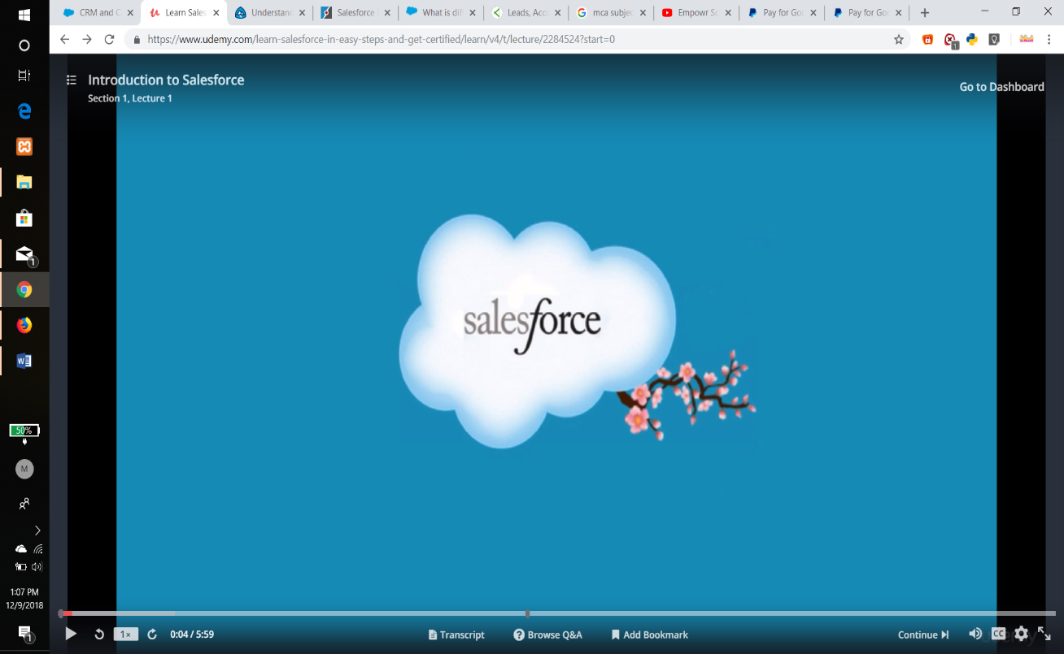

What they say it's course dotcom.

It's a global cloud computing company founded by my Benioff In the year 1999.

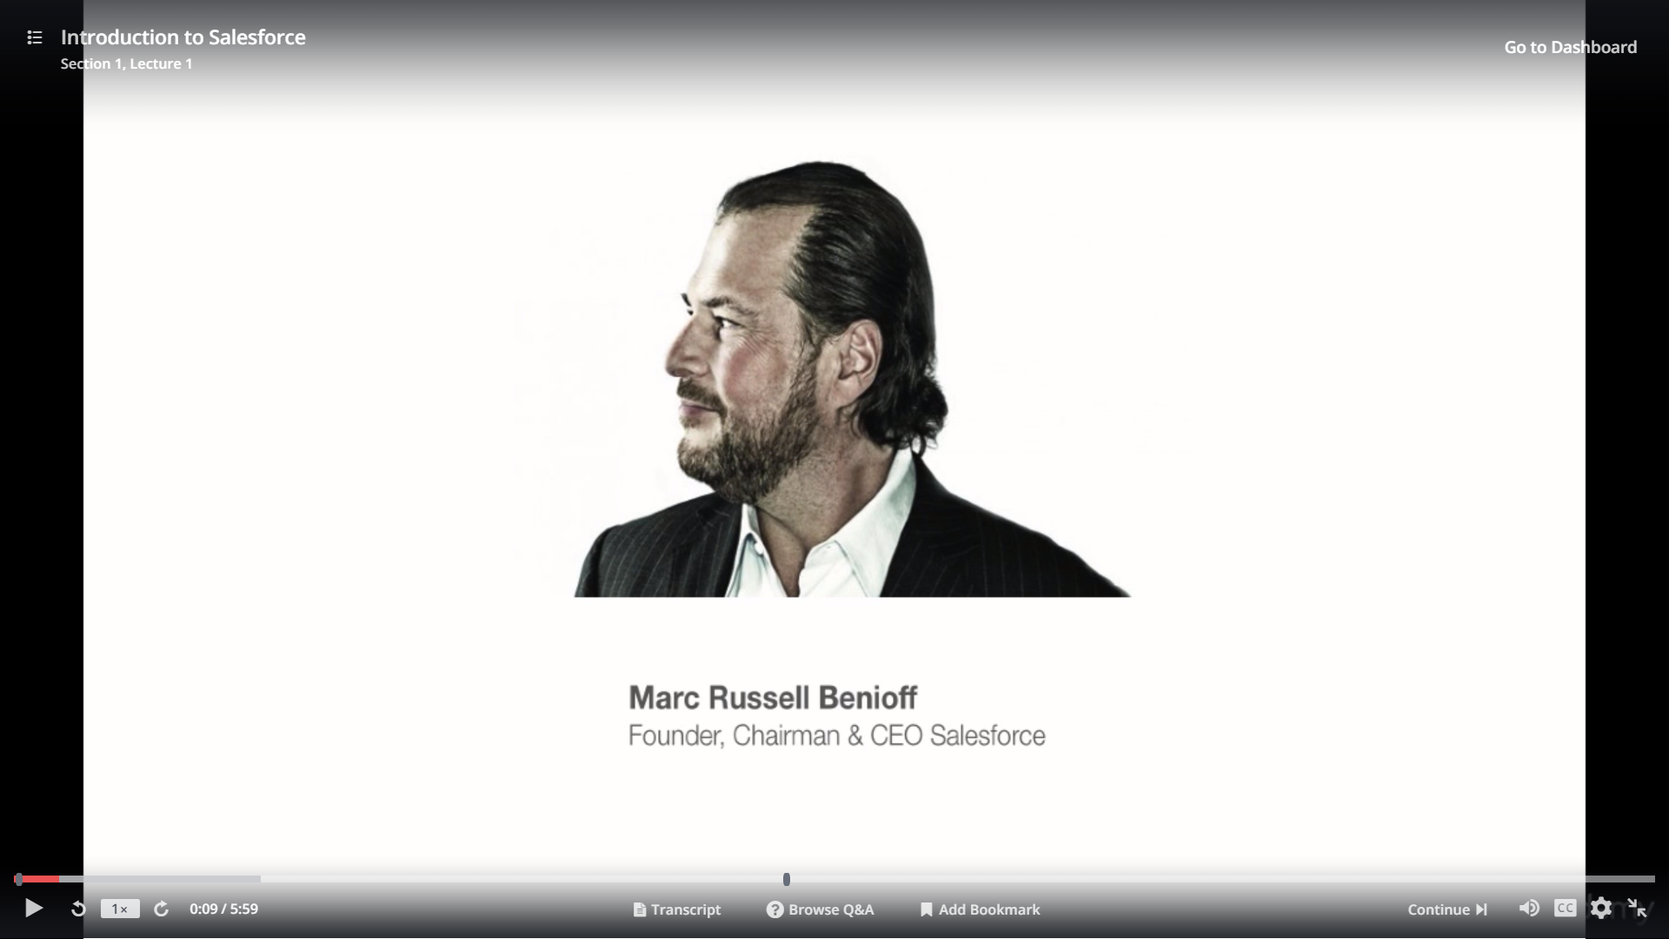

The company had the gall to offer CRM on the cloud before I dive in.

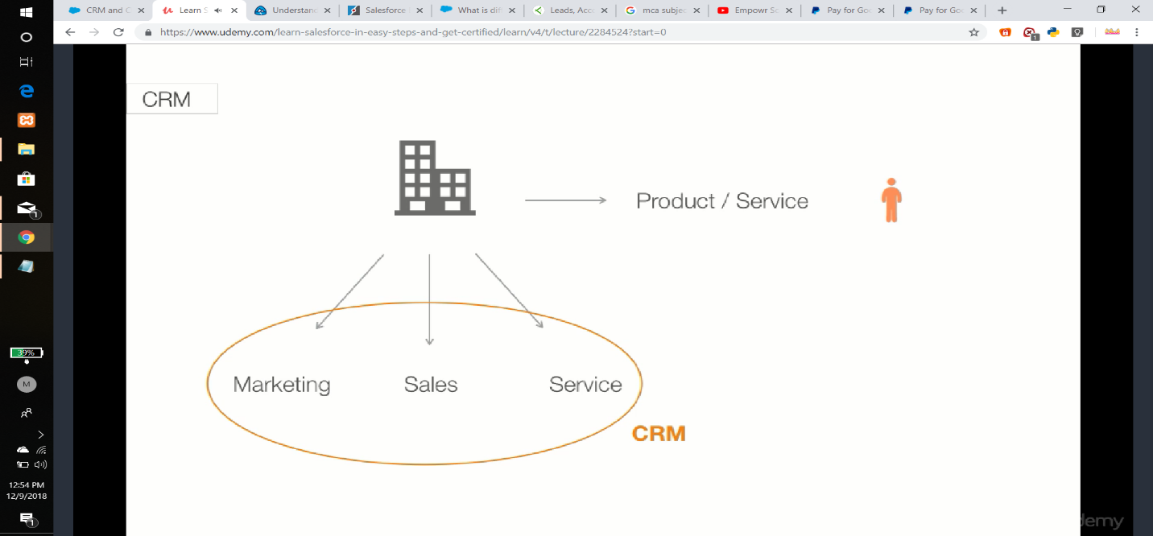

Let me explain what is the item is every company out there is selling a product or service Dumanis the interaction with customer.

The company needs the marketing the sales team and servicing an application that can help manage all these processes is called the customer relationship management.

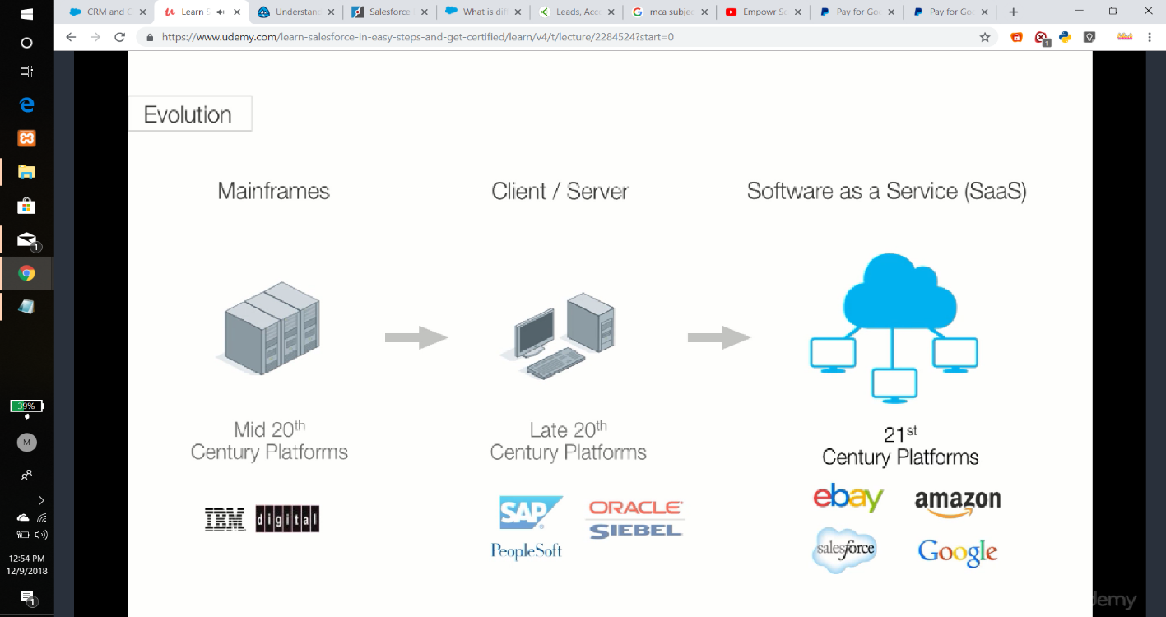

In short CRM they can see the evolution of platforms over time in mid-20's we have IBM and in the late

20s we have ACP and Oracle dominate the market with client server architecture.

And right now we see a migration to the cloud or the multi-tenant architecture market unseasoned architecture.

A single instance of software application serves multiple customers each customer Colleton tenants may be given the ability to customize some parts of the application multi-tenancy can be economical because software development and maintenance costs are shared.

But broadband penetration being very high.

Lots of companies are leveraging this technology.

Let's look at the literally millions of individuals and companies are running their complete stores on line and Google which offers email and Google Docs for the enterprise.

But a single instance of the application is serving millions of users.

Similarly sales force offers on demand CRM the on demand model has lot of advantages available anywhere anytime as long as you're connected to the Internet.

The platform is easily scalable.

You can add as many users as you want by purchasing additional licenses and periodic upgrades at all don't automatically at any point in time.

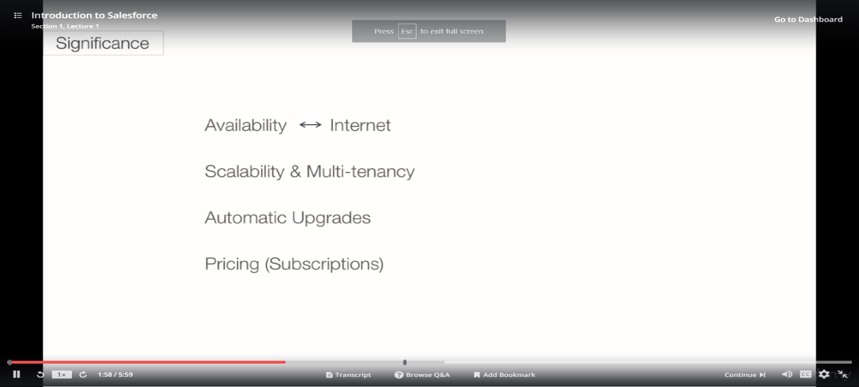

Every company using sales force or goal is running the latest version of the software.

And the pricing of sales force is subscription based every user needs a license to log in.

The platform is pretty robust and can easily scale up to a few thousands of users without hindering performance.

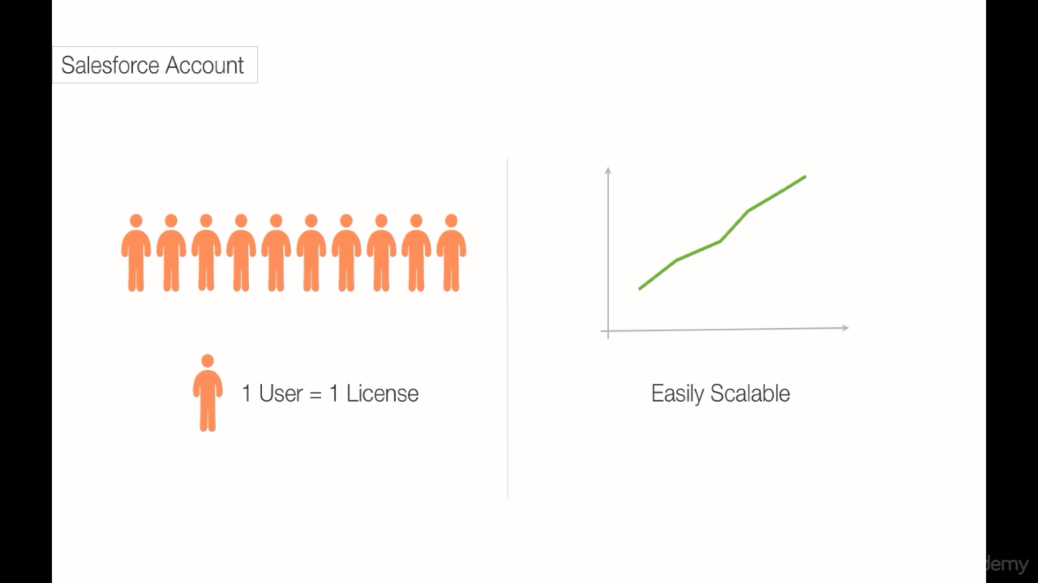

Most of the infrastructure services like running the application service web service are making sure that the network is up supporting multiple operating systems database maintenance and disaster recovery are taken care of by the service provider.

Similarly the application services like providing security supporting multiple languages and multiple currencies providing an API for integration are also taken care of by the service Broida and lastly operation services like monitoring periodic upgrades backup are also taken by the self-employed.

If you ever work as a complete stack developer responsible for building and maintaining the application you'll be able to appreciate the platform especially when the service provider takes care of infrastructure applications services and operations that have a couple of standard applications that are offered by force Sales Cloud Service Cloud and Marketing Cloud.

All these applications run on the forest are complex.

That blubbers can also build custom applications and start compatible but even extend the functionality of standard applications that are more than 100000 customers using sales force.

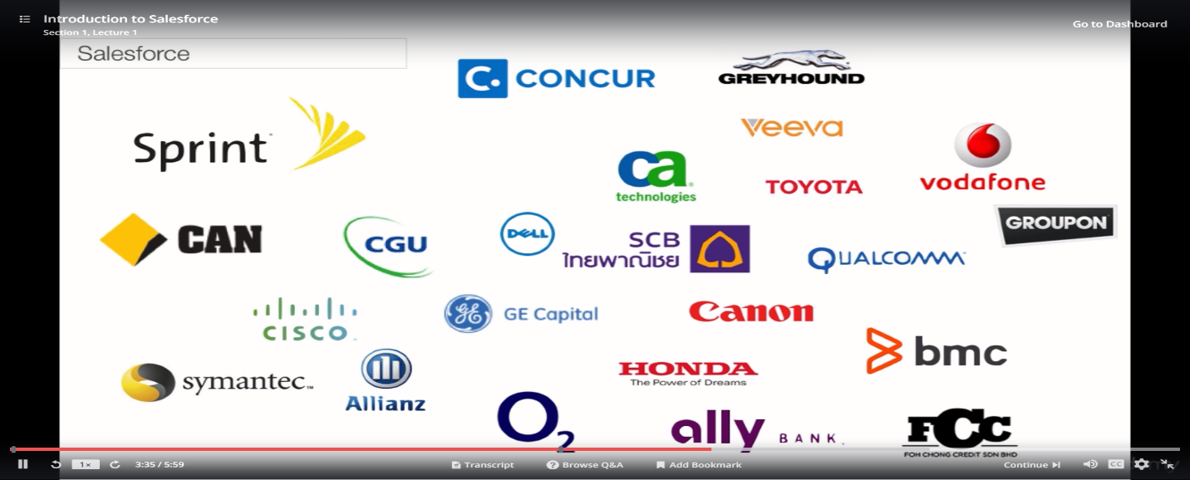

I have a couple of them on the slide.

They present pretty much every domain possible the local IP banking consumer electronics transportation communication automotive and even nonprofits that are different trolls on this platform one could work as a leper or an administrator or a consultant.

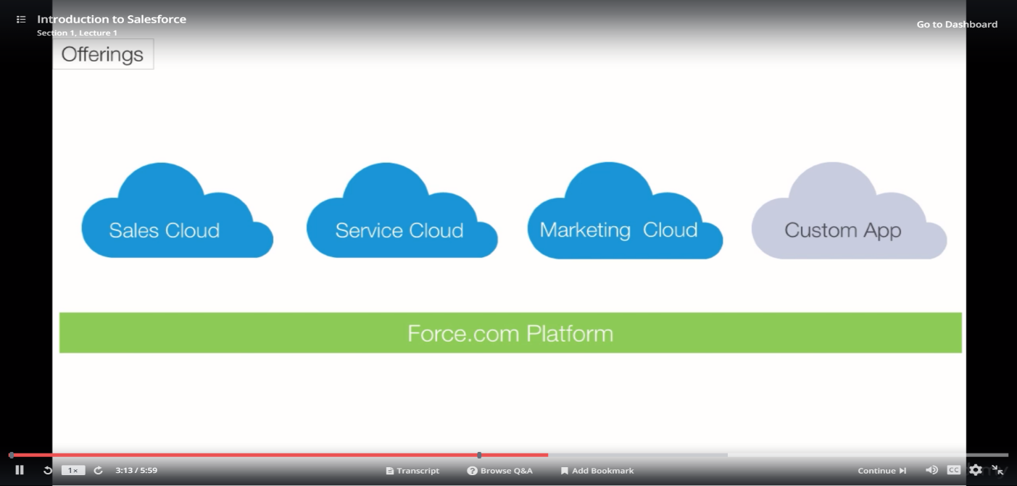

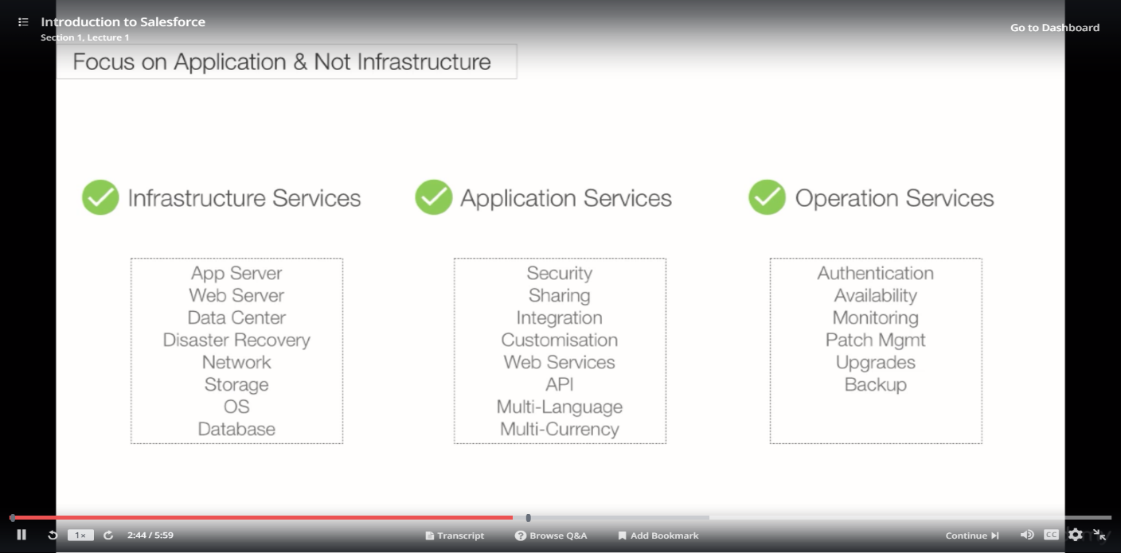

Sales Force has designed so deficient tracks that all these street ords you have the track starting with force you don't want in 4:0 one.

One would learn how to build an application using the Post dot com platform all the way from building your data model business logic and the user interface managing data and building reports and dashboards or complementary and there is no programming and force you don't want.

Once you're comfortable with these concepts you can take the debt 4:0 one set of question and then you can move on to them.

I don't want to end up like 0 1 one would learn the concepts of epics and vision force to tackle any business requirement that cannot be built using the declarative syntax using a picks and which of course you can build any kind of complex functionality.

Epic's is a programming language used to build any kind of complex business logic and vision force which is a tag based language is used to build the UI.

Once you are comfortable with these concepts you can take the 5:0 and said Kishan exam and put the administrator track.

It starts with Adium 2 0 1 1 would learn best practices on how to set up configure support and marketing functionality on see if post-rock advanced administration covers topics such as managing data enhancing and user productivity and expanding sales for CRM to help you work more efficiently and get more from its core CRM and for the consistent track you start with Adium to 0 1 like your administrator track and then get into the sales cloud or the service cloud Consul-General sales club canceled entrail is focused on best practices of Sales Cloud implementation and service cloud council control is focused on best practices of call center implementation.

I take this approach of showing you how to build the application from scratch and introduce you to some advance that 5:0 one programming concepts.

If you understand and follow through all the course material you should be able to easily pass the debt for zero once had Ishan the best path.

If the user can sign up for a recount in the next lecture I should show you how to set up your account.

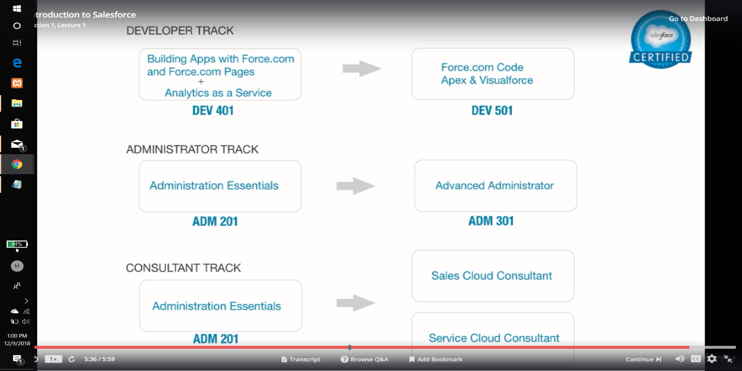

----------------------------------\*\*\*\*\*\*\*\*\*\*\*\*\*\*Lecture 1 Completed\*\*\*\*\*\*\*\*\*\*\*\*\*\*\*------------------------------